

*Faculty of Engineering and the Built Environment*

*Department of Electrical Engineering*

**Stereo Amplifier with Sensor Display**

UCT Vac Work Project

Name: Sylvan Morris

Student Number: MRRSYL001

Date: 7 March 2017

Contents

1 Base Amplifier 3

2 Rectifier 3

3 Amps 4

4 Temperature Sensors 4

5 Voltage Sensor 5

6 Ammeter 6

7 Arduino 6

8 7-Segment Displays 7

9 Improvements 8

10 References 8

# Base Amplifier

The amplifier came in a metal box. It contained a transformer and a bridge rectifier. There is an amp for left and right and they can take RCA and 3.5mm Aux as inputs. There are 1 set of output connector (banana socket) for left and right. There is a common heatsink used by both the amps.

# Rectifier

The rectifier is a full bridge rectifier, its powered by mains 230V AC which is then stepped down to ~17V DC on the positive rail and ~ -17v DC on the negative. The rectifier has a ripple frequency of 100Hz and there was a 2200uF cap between each rail and GND. This gave a ripple voltage of almost 0.5V which was quite terrible. I added 3x 4700uF per line to try decrease that ripple. The ripple is now smaller than the noise on the positive rail, so its negligible. The rectifier Veroboard is an absolute mess of new additions and globs of solder.

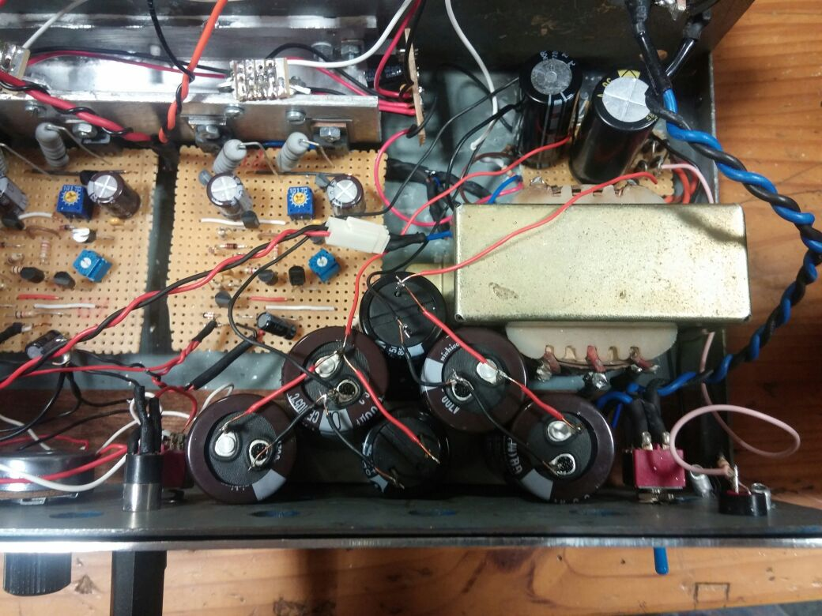

The new caps are simply stuck where I could find space so it’s a bit of squish with some exposed wires.

# Amps

The Amps have been wired so that the left amp controls the left audio from the RCA connectors and 3.5mm jack and outputs it to the left set of banana plugs. The left potentiometer controls the left amp’s volume. The volume pots are linear.

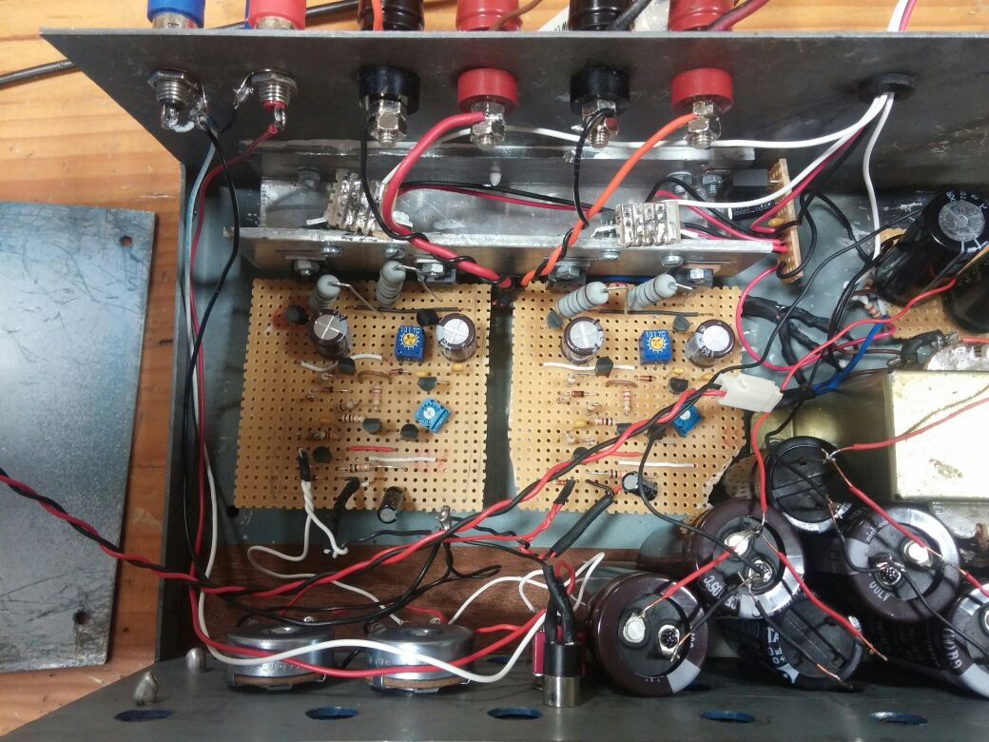

# Temperature Sensors

The temperature sensors are MCP9700s. They have a voltage to temp ratio of 10mV/C and 0 C is at 500mV. There are two temp sensors in the box. One for each amp. The temp of the right side is also affected by a 7805CT which supplies a regulated 5V to the Arduino and 7-segments. The left sensor signal line goes to the A1 pin on the Arduino and the right goes to A2. The signal lines both have RC filters on them with a 10kΩ resistor and a 33 $µ$ F, which gives a frequency of 0.5Hz.



$$f=\frac{1}{2πRC}$$

# Voltage Sensor

The voltage sensor consists of a voltage divider and a decoupling capacitor.

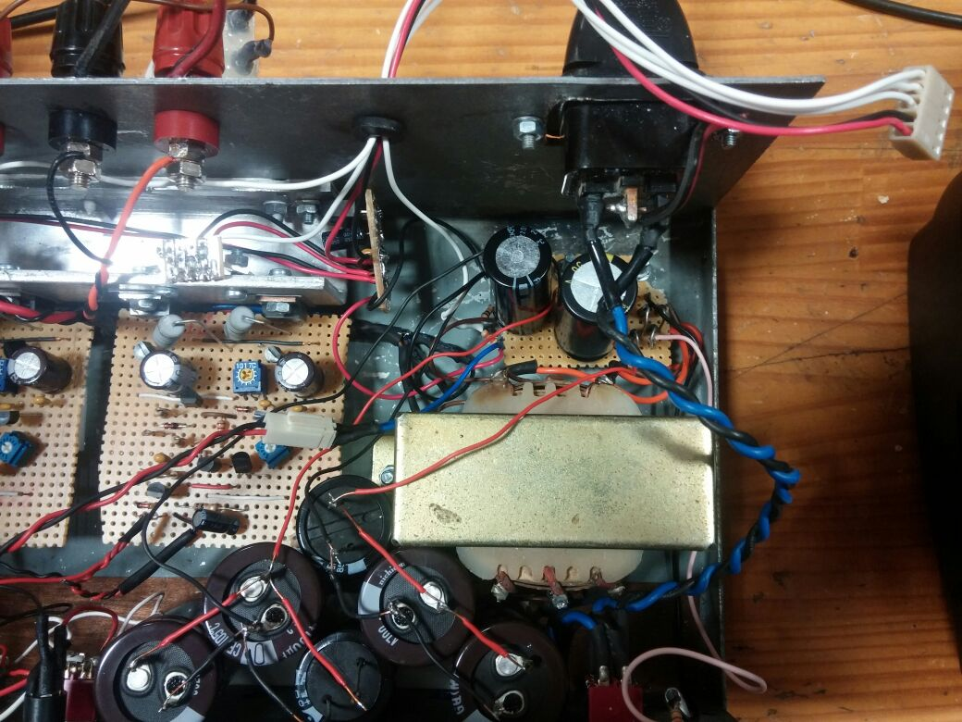

The voltage divider is a 40kΩ and a 10kΩ between the positive rail and ground. The 40k is connected to the positive rail and the 10k which is connected to GND. The signal line leaves from above the 10k which assuming the signal line draws no current (it will), will have a voltage which a fifth of the total positive rail (w.r.t GND). The signal line has a 10nF decoupling capacitor on the Arduino Veroboard.

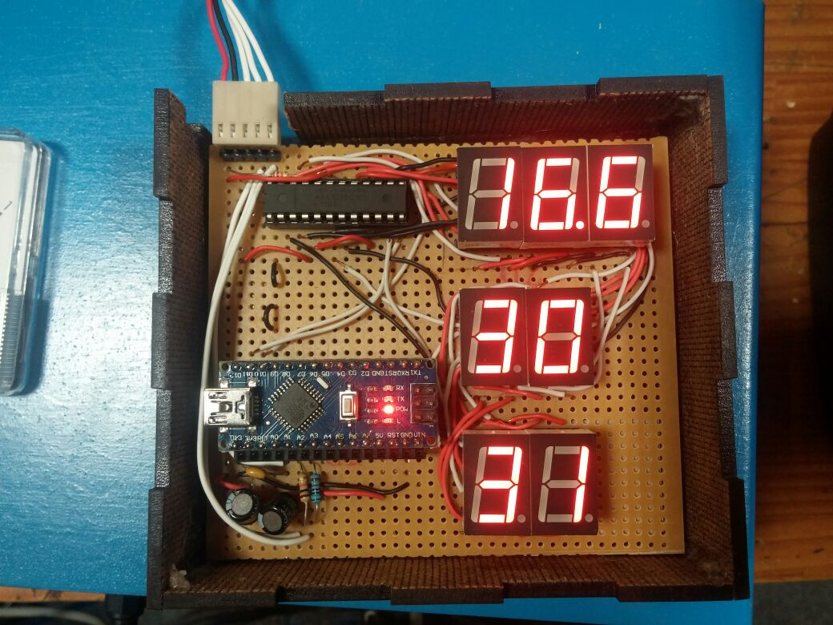

Decoupling for Voltage

Right Temp

Left Temp

Voltage Sensor

GND

5V

# Ammeter

The ammeter is a 1 A needle ammeter it’s simply connected by a 2 pin Molex between the positive rail and the circuit. Be careful when opening the lid, so that the leads aren’t damaged.

# Arduino

The Arduino is a Nano. It was programmed using the Windows Arduino IDE, the Online editor gave me issues when combining the LedControl.h library and the temperature sensors, when the setup line for a LedControl object was added it would give bad temp values (117℃ instead of 27℃). LedControl.h is the only library used and it is specifically for MAX7219 LED driver. The code is all in a GitHub repository.

# 7-Segment Displays

The 7-segments are run using a MAX7219 LED Driver. It simplifies the whole system by only needing 3 inputs from the Arduino to run up to 8 Drivers with 8x7-Segments each.

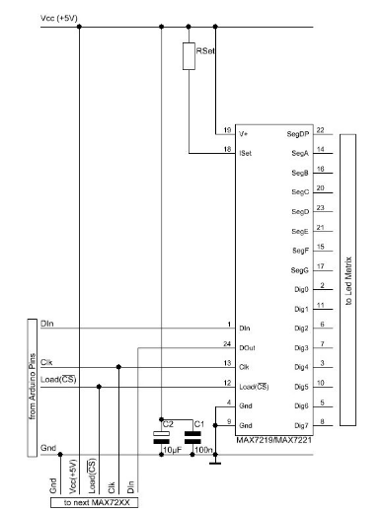

The above schematic shows how the Arduino and the MAX chip are connected. The only difference is that the capacitors are on the regulator in the box not on the Veroboard with the LEDs. The RSet resistor used is a 27kΩ. Though if you are using LEDs with different current requirements to the SMA42056s I used, there is a table of values in the MAX7219/7220 datasheet.

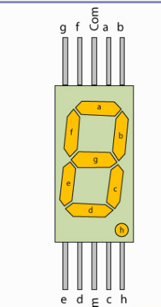

The SMA42056s have a common cathode (GND) and the letters are the same for MAX7219 schematic and SMA42056 schematic.

The connections between the Arduino and the driver are DIN(D10), Clk(D11) and Load (CS)(D13). The 7 Segments are effectively all in parallel.

# Improvements

* Use logarithmic pots for volume control.
* Create a better power supply.
* Get a different heatsink for 7805CT.

# References

* MCP9700 datasheet: <https://cdn.sparkfun.com/datasheets/E-Textiles/Lilypad/38512_SPCN.pdf>
* Arduino code for MCP9700: <http://starter-kit.nettigo.eu/2010/how-to-measure-temperature-with-arduino-and-mcp9700/>
* Arduino Code: <https://github.com/skrapi/Ampilifer-with-added-Sensors.git>
* MAX7219 datasheet: <https://datasheets.maximintegrated.com/en/ds/MAX7219-MAX7221.pdf>